W311R (W311R+)-How to limit the computer to access the Internet by client Filter function (R)?
Product line: wireless Question category: function configaration

Q：Why we should configure Client Filter?
A：To benefit your further management to the computers in the LAN, you can control some PCs with certain IP address access to Internet by setting Client filter to achieve it.

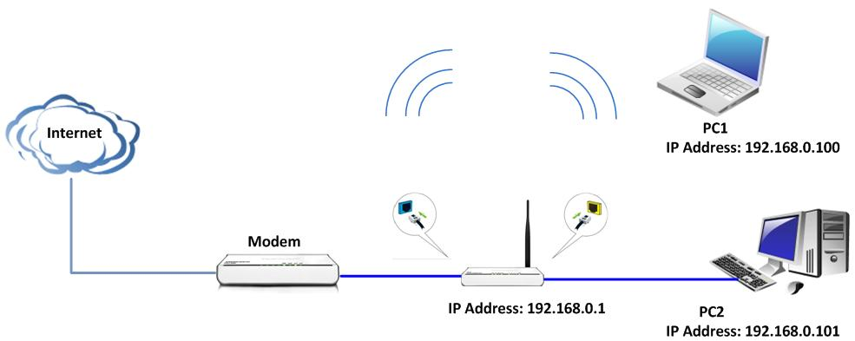

The steps are followings:

- Login to the management page of the router.
- Click Security Settings→Client Filter in the gray menu on the left.

On the right size of the page, please tick Client Filtering Settings.
For example, we want to limit the computer with IP address during 192.168.80.100~192.168.80.200 to access the internet from 8:00am to 18:00pm from Monday to Friday. And the computers with other IP Address can access the internet. You can set the router following the picture as below.

